Selenium Assignments

A.

1)Open “amazon.in”

2)Search mobile phones

3)Verify the title using assertion

4)Click the first phone details

5)Click add to cart

6)Select cart

ANSWER

package assignment;

import java.time.Duration;

import java.util.Set;

import org.openqa.selenium.By;

import org.openqa.selenium.Keys;

import org.openqa.selenium.chrome.ChromeDriver;

import org.openqa.selenium.support.ui.ExpectedConditions;

import org.openqa.selenium.support.ui.WebDriverWait;

import org.testng.Assert;

import org.testng.annotations.BeforeMethod;

import org.testng.annotations.BeforeTest;

import org.testng.annotations.Test;

public class amazon {

ChromeDriver driver;

@BeforeMethod

public void setup()

{

driver=new ChromeDriver();

}

@BeforeTest

public void urlloading()

{

driver.get("https://www.amazon.in/");

}

@Test

public void test()

{

driver.findElement(By.xpath("//input[@id='twotabsearchtextbox']")).sendKeys("mobile phones",Keys.ENTER);

String actualtitle="Amazon.in : mobile phones";

String expectedtitle=driver.getTitle();

Assert.assertEquals(actualtitle, expectedtitle);

String parentWindow=driver.getWindowHandle();

System.out.println("parent window Titile"+driver.getTitle());

driver.findElement(By.xpath("//*[@id=\"search\"]/div[1]/div[1]/div/span[1]/div[1]/div[3]/div/div/div/div/span/div/div/div/div[2]/div/div/div[1]/h2/a")).click();

Set<String> allwindowhandles=driver.getWindowHandles();

for(String handle:allwindowhandles)

{

System.out.println(handle);

if(!handle.equalsIgnoreCase(parentWindow))

{

driver.switchTo().window(handle);

driver.findElement(By.xpath("/html/body/div[2]/div/div[5]/div[3]/div[1]/div[4]/div/div[1]/div/div[1]/div/div/div[2]/div/div[2]/div/form/div/div/div[38]/div[1]/span/span/span/input")).click();

WebDriverWait wait=new WebDriverWait(driver,Duration.ofSeconds(30));

wait.until(ExpectedConditions.visibilityOfElementLocated(By.xpath("//*[@id=\"attach-sidesheet-view-cart-button\"]/span/input")));

driver.findElement(By.xpath("//*[@id=\"attach-sidesheet-view-cart-button\"]/span/input")).click();

}

}

}

}

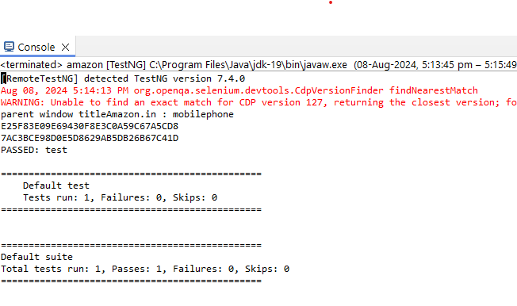

2)

1)Open <https://rishiherbalsindia.linker.store/>

2)Click y account and register your details

3)click login button and login

4)Search “Herbal Agro Growth” in search bar

5)Click add to wish list and add that product to wish list

6)Then click on link “skin” and add “aloe fairness cream “to wish list

7)click “All” link . Then click” health” link ,After that click “safety” link one after the other

8)Scroll down to the bottom of the page &click “about us”

9)Take screenshot of the element “privacy policy”

10)Check the response code of the link” <https://rishiherbalsindia.linker.store/>”

ANSWER

**package** assignments;

**import** java.io.File;

**import** java.net.HttpURLConnection;

**import** java.net.URL;

**import** org.openqa.selenium.By;

**import** org.openqa.selenium.JavascriptExecutor;

**import** org.openqa.selenium.Keys;

**import** org.openqa.selenium.OutputType;

**import** org.openqa.selenium.WebDriver;

**import** org.openqa.selenium.WebElement;

**import** org.openqa.selenium.chrome.ChromeDriver;

**import** org.openqa.selenium.io.FileHandler;

**import** org.testng.annotations.BeforeMethod;

**import** org.testng.annotations.BeforeTest;

**import** org.testng.annotations.Test;

**public** **class** Rishiherbalindia {

WebDriver driver;

@BeforeTest

**public** **void** setup()

{

driver=**new** ChromeDriver();

}

@BeforeMethod

**public** **void** urlloading()

{

driver.get("https://rishiherbalindia.linker.store/");

}

@Test

**public** **void** test1() **throws** Exception

{

driver.findElement(By.*xpath*("//*[@id=\"top-links\"]/ul/li[1]/a")).click();

//register

driver.findElement(By.*xpath*("//*[@id=\"top-links\"]/ul/li[1]/ul/li[1]/a")).click();

driver.findElement(By.*xpath*("//*[@id=\"ls-signup-overlay-v1\"]/div/div/div[2]/form/div[1]/input")).sendKeys("heera113@gmail.com");

driver.findElement(By.*xpath*("//*[@id=\"ls-signup-overlay-v1\"]/div/div/div[2]/form/div[2]/input")).sendKeys("Heera@344");

driver.findElement(By.*xpath*("//*[@id=\"ls-signup-overlay-v1\"]/div/div/div[2]/form/div[3]/label/input")).click();

driver.findElement(By.*xpath*("//*[@id=\"ls-signup-overlay-v1\"]/div/div/div[2]/form/button")).click();

//Login

driver.findElement(By.*xpath*("//*[@id=\"cont-login-with-email\"]/form/div[1]/input")).click();

driver.findElement(By.*xpath*("/html/body/div[2]/div/div/div[2]/div[1]/form/div[1]/input")).sendKeys("heera113@gmail.com");

driver.findElement(By.*xpath*("//*[@id=\"cont-login-with-email\"]/form/div[2]/input")).sendKeys("Heera@344");

driver.findElement(By.*xpath*("/html/body/div[2]/div/div/div[2]/div[1]/form/button[1]")).click();

//search

driver.findElement(By.*xpath*("//*[@id=\"search\"]/input")).sendKeys("Herbal Agro Growth Booster",Keys.***ENTER***);

//click cart

driver.findElement(By.*xpath*("//*[@id=\"cart-btn-toggle\"]/i")).click();

//click herbal agro growth booster

driver.findElement(By.*xpath*("//*[@id=\"content\"]/div[3]/div[1]/div/div/div[1]/div/a/img")).click();

//herbal agro growth booster add to wish list

driver.findElement(By.*xpath*("//*[@id=\"prod_cont\"]/div/div[4]/button[1]")).click();

// click skin

driver.findElement(By.*xpath*("//*[@id=\"menu\"]/ul/li[4]/a")).click();

//click aloe fairness cream

driver.findElement(By.*xpath*("//*[@id=\"content\"]/div[3]/div[1]/div/div/div[1]/div/a/img")).click();

//aloe fairness cream add to wish list

driver.findElement(By.*xpath*("//*[@id=\"prod_cont\"]/div/div[4]/button[1]")).click();

//click all

driver.findElement(By.*xpath*("//*[@id=\"column-left\"]/div[1]/div[2]/ul/li[1]/a")).click();

//click health

driver.findElement(By.*xpath*("//*[@id=\"menu\"]/ul/li[2]/a")).click();

//click safety

driver.findElement(By.*xpath*("//*[@id=\"menu\"]/ul/li[3]/a")).click();

//scroll

JavascriptExecutor js=(JavascriptExecutor) driver;

js.executeScript("window.scrollBy(0,1000)", "");

driver.findElement(By.*xpath*("/html/body/div/footer/div[1]/div/div[2]/div[2]/div/ul/li[2]/a")).click();

//screenshot

WebElement cut=driver.findElement(By.*xpath*("/html/body/div/footer/div[1]/div/div[2]/div[4]/div/ul/li[1]/a"));

File screenshot=cut.getScreenshotAs(OutputType.***FILE***);

FileHandler.*copy*(screenshot, **new** File("./Screenshots//herbals.png"));

//response code

URL url=**new** URL("https://rishiherbalindia.linker.store/");

HttpURLConnection connection=(HttpURLConnection)url.openConnection();

connection.connect();

**if**(connection.getResponseCode()==200)

{

System.***out***.println("Valid URL");

}

**else**

{

System.***out***.println("Invalid URL");

}

}

}

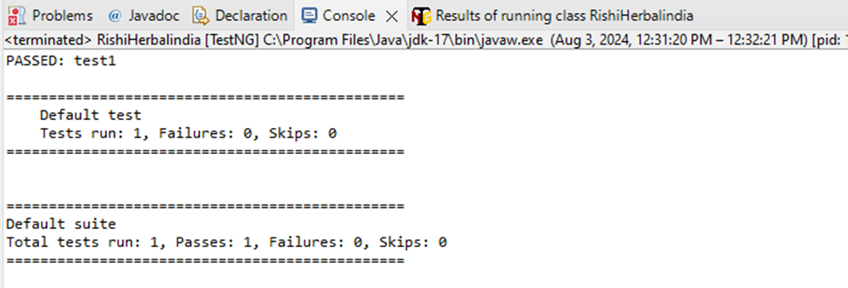OUTPUT

C.

**Blaze demo website**

**1)Register**

package assignments;

import org.openqa.selenium.By;

import org.openqa.selenium.WebDriver;

public class Blazedemo_register {

WebDriver driver;

By BDname=By.name("name");

By BDcompany=By.name("company");

By BDemail=By.id("email");

By BDpassword=By.id("password");

By BDCpassword=By.id("password-confirm");

By register=By.xpath("//*[@id=\"app\"]/div/div/div/div/div[2]/form/div[6]/div/button");

public Blazedemo_register(WebDriver driver)

{

this.driver=driver;

}

public void setvalues(String name,String company,String email,String password,String cpassword)

{

driver.findElement(BDname).sendKeys(name);

driver.findElement(BDcompany).sendKeys(company);

driver.findElement(BDemail).sendKeys(email);

driver.findElement(BDpassword).sendKeys(password);

driver.findElement(BDCpassword).sendKeys(cpassword);

}

public void register()

{

driver.findElement(register).click();

}

}

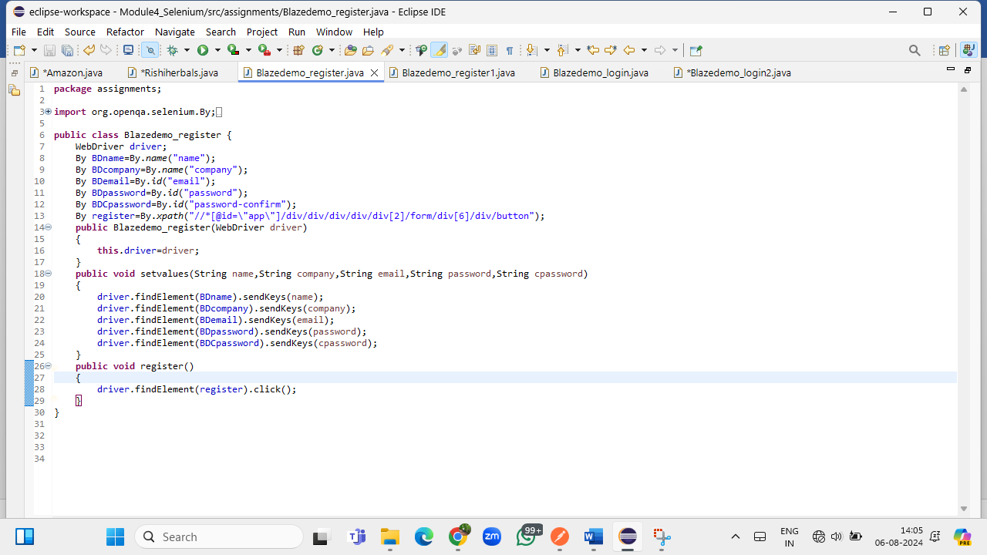

OUTPUT

2)register1

package assignments;

import org.openqa.selenium.WebDriver;

import org.openqa.selenium.chrome.ChromeDriver;

import org.testng.annotations.BeforeMethod;

import org.testng.annotations.BeforeTest;

import org.testng.annotations.Test;

public class Blazedemo_register1 {

WebDriver driver;

@BeforeTest

public void setup()

{

driver=new ChromeDriver();

}

@BeforeMethod

public void urlloading()

{

driver.get("https://blazedemo.com/register");

}

@Test

public void register()

{

Blazedemo_register ob=new Blazedemo_register(driver);

ob.setvalues("abc", "luminar", "abc@gmail.com", "abc123", "abc123");

ob.register();

}

}

OUTPU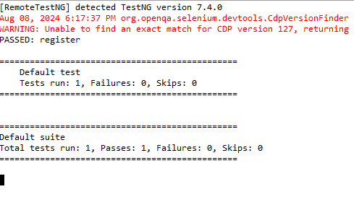T

2)Login

package assignments;

import org.openqa.selenium.By;

import org.openqa.selenium.WebDriver;

public class Blazedemo_login {

WebDriver driver;

By dbemail=By.name("email");

By dbpassword=By.id("password");

By login=By.xpath("//*[@id=\"app\"]/div/div/div/div/div[2]/form/div[4]/div/button");

public Blazedemo_login(WebDriver driver)

{

this.driver=driver;

}

public void setvalues(String email,String password)

{

driver.findElement(dbemail).sendKeys(email);

driver.findElement(dbpassword).sendKeys(password);

}

public void login()

{

driver.findElement(login).click();

}

}

4)login1 package assignments;

import org.openqa.selenium.WebDriver;

import org.openqa.selenium.chrome.ChromeDriver;

import org.testng.annotations.BeforeMethod;

import org.testng.annotations.BeforeTest;

import org.testng.annotations.Test;

public class Blazedemo_login2 {

WebDriver driver;

@BeforeTest

public void setup()

{

driver=new ChromeDriver();

}

@BeforeMethod

public void urlloading()

{

driver.get("https://blazedemo.com/login");

}

@Test

public void testlogin()

{

Blazedemo_login ob=new Blazedemo_login(driver);

ob.setvalues("abc@gmail.com", "abc123");

ob.login();

}

}

